

**Medicare Fraud Detection**

Project Report

**BIG DATA FRAMEWORKS**

**(CSE3120)**

**School of Computer Science and Engineering (SCOPE)**

**VIT Chennai**

**Winter 2022-2023**

**Slot: G1**

**Course Faculty: Prof Mansoor Hussain D**

**Submitted by**

**HIMANSHU MITTAL 20MIA1035**

**KUSHAGRA JOSHI 20MIA1054**

**SANJAY KUMAR 20MIA1008**

**АCKNOWLЕDGЕMЕNT**

We would like to express our special thanks and gratitude to our teacher **Prof Mansoor Hussain D**, faculty of school of Computer Science and Engineering who gave us the golden opportunity to do this wonderful project titled **medical fraud detection**, and also for providing us with proper guidance and suggestions to develop this project. This helped us in research and we came across many new things. Secondly, we would also like to thank our friends and group mates who helped us а lot in finalizing this project within the limited time frame. We would also like to thank our family for their consistent support throughout this time.

Our exploratory analysis on Medicare fraud detection involves building and assessing three learners on each dataset. Based on the Area under the Receiver Operating Characteristic (ROC) Curve performance metric, our results show that the Combined dataset with the Logistic Regression (LR) learner yielded the best overall score at 0.816, closely followed by the Part B dataset with LR at 0.805. Overall, the Combined and Part B datasets produced the best fraud detection performance with no statistical difference between these datasets, over all the learners. Therefore, based on our results and the assumption that there is no way to know within which part of Medicare a physician will commit fraud, we suggest using the Combined dataset for detecting fraudulent behaviour when a physician has submitted payments through any or all Medicare parts evaluated in our study.

**CONTENTS**

|  |  |
| --- | --- |
| 1. Abstract | 4 |
| 1. Introduction | 5 |
| 1. Literature Survey | 9 |
| 1. Dataset | 11 |
| 1. Data Processing | 16 |
| 1. Fraud labelling | 19 |
| 1. Methodology | 20 |
| 1. Results and discussion | 23 |
| 1. Conclusion | 26 |
| 1. Future Work | 27 |
| 1. References | 28 |

**ABSTRACT**

The aim of this project is to develop a machine learning-based Medicare fraud detection system to help prevent fraudulent activities in the healthcare industry. The fraudulent activities in the Medicare system cost taxpayers billions of dollars each year, and it is essential to have a system that can detect such activities in real-time. The proposed system will use historical Medicare claims data and other relevant information to identify patterns and anomalies that may indicate fraudulent activities. The system will be developed using various machine learning algorithms such as random forest, logistic regression, and support vector machines. The accuracy of the developed model will be evaluated using precision, recall, F1-score, and AUC metrics. The system's usability and performance will also be evaluated using real-world Medicare data. The developed system can be used by healthcare organizations and government agencies to identify and prevent fraudulent activities in the Medicare system, which will ultimately help reduce healthcare costs and improve patient care.

**MOTIVATION**

Medicare fraud is a growing problem that costs taxpayers billions of dollars each year and puts vulnerable populations at risk of receiving substandard care. Developing effective methods for detecting and preventing Medicare fraud is crucial to ensure that the program can continue to provide necessary healthcare services to those who need it most. By undertaking a project focused on Medicare fraud detection, students can not only gain valuable skills in data analysis and machine learning, but also contribute to the development of solutions that can help address this pressing issue.

**INTRODUCTION**

Healthcare is important to many people in the United States (U.S.), but the high costs of health-related services mean that many people can't get the care they need. Because of this, the U.S. government has set up and paid for programmes, such as Medicare, that help people who need medical care but don't have enough money to pay for it. There are a number of problems with healthcare and medical insurance systems, such as a growing population or bad actors (such as fraudulent or potentially fraudulent doctors or providers), which reduces the amount of money set aside for these programmes. The number of people 65 and older in the U.S. has grown by 28% from 2004 to 2015, while the number of people under 65 has grown by only 6.5%. One reason for this is that healthcare has gotten better, which has helped people live longer. The U.S. healthcare spending has gone up, with an annualised growth rate of 4.0% (adjusted for inflation) between 1995 and 2015. This is because the population has grown, especially among the elderly, and medical technology has improved. Most likely, spending will keep going up, making it even more important to have an efficient and cost-effective healthcare system. Fraud, waste, and abuse are big problems in healthcare, and even though people are trying to stop them, they aren't making a big difference in the amount of money they cost. In this study, we look at fraud, and when we say "fraud" in this paper, we also mean "waste" and "abuse." The Federal Bureau of Investigation (FBI) says that 3–10% of healthcare costs are due to fraud, which costs between $19 billion and $65 billion each year. Medicare accounts for 20% of all healthcare spending in the U.S. If effective fraud detection methods were used, Medicare alone could recover between $3.8 billion and $13 billion in costs.

The majority of the time, auditors and investigators in the healthcare industry will manually sift through a large number of records in order to look for potentially fraudulent or suspicious actions. This is the primary method for detecting fraud. This laborious procedure, which involves sifting through vast volumes of data, through, which can be time-consuming and relatively ineffective in comparison to more automated methods such as data mining and machine learning when it comes to detecting fraud. Because technology advancements now make it possible to store large amounts of data, for example, in electronic health records (EHR), the volume of information that is used in the healthcare industry is continuing to grow. This is making "Big Data" an increasingly important concept. The ability to perform data mining and machine learning on Big Data is increasing along with the advancement and increased usage of technology. This has the potential to enhance the current condition of healthcare as well as medical insurance programmes so that patients can receive quality medical care. The Canters for Medicare Services (CMS) participated in this initiative by publishing "Big Data" Medicare datasets to aid in the identification of fraud, waste, and abuse that occurs inside Medicare. According to a statement issued by CMS, "those individuals who are set on misusing Federal health care programmes can cost taxpayers billions of dollars while putting beneficiaries' health and welfare in jeopardy." As Medicare continues to provide services to an increasing number of people, the impact of these losses and hazards will become more severe. On the website for the Centres for Medicare Services (CMS), there are numerous datasets that users can access.

The five Vs of Big Data are Volume, Velocity, Variety, Veracity, and Value. Volume refers to large volumes of data, Velocity refers to the rapid rate at which new data is generated/collected, and Variety refers to the level of complexity of the data (for example, incorporating

Veracity symbolises the genuineness of the data, and Value indicates how good the quality of the data is in relation to the expected results.

CMS's databases display many of these Big Data characteristics. These databases are Huge Volume because they contain annual claim records for all physicians in the United States who submit to Medicare. CMS provides data for the prior year every year, increasing the Big Volume of available data. The datasets each have roughly 30 variables, ranging from provider demographics and procedure kinds to payment amounts and the number of services performed, making them Big Variety.

Furthermore, because it integrates three significant (but distinct) Medicare data sources, the Combined dataset used in our analysis automatically contains Big Variety data. We believe that these datasets are credible, valid, and representative of all known Medicare provider claims since CMS is a government programme with clear quality controls and thorough documentation for each dataset, showing Great Veracity. According to research undertaken by our research department and others, this data can be utilised to detect fraudulent behaviour, giving it a high value. Furthermore, because it contains the largest known repository of real-world fraudulent medical providers in the United States, the LEIE dataset could be termed Big Value.

This research makes two contributions. Initially, we present in-depth discussions on Medicare Big Data processing as well as exploratory experiments and analysis to demonstrate the best learners and datasets for detecting Medicare provider claims fraud. Data imputation, deciding which variables (dataset characteristics) to preserve, aggregating the data from the procedure-level to the provider-level to match the level of the LEIE dataset for fraud label mapping, and constructing the Combined dataset are our unique data processing steps.

It should be noted that the fraud labels are used to assess fraud by leveraging previous exclusion information as well as Medicare payments made to currently excluded providers. Second, the resulting processed datasets are referred to as Big Data, and as a result, for our fraud detection experiments, we utilize these datasets.

Use Spark on top of a Hadoop YARN cluster capable of handling these large dataset sizes. The four Medicare datasets were trained and verified using fivefold cross-validation for our experiments, and the process was repeated ten times. We build the Random Forest (RF), Gradient Tree Boosting (GTB), and Logistic Regression (LR) models from the Apache Spark 2.3.0 Machine Learning Library, and utilize the Area under the ROC Curve (AUC) statistic to assess fraud detection performance. We chose these learners because they are widely used and provide reasonably acceptable performance for our exploratory research of fraud detection performance in Medicare using Big Data. We evaluate statistical significance utilizing the Analysis Of Variance (ANOVA) and Tukey's Honest Significant Difference (HSD) tests to add robustness to the results. According to our findings, the Combined dataset with LR produced the greatest overall AUC of 0.816, followed by the Part B dataset with LR at 0.805. Furthermore, the Part B dataset produced the greatest results for GBT and RF, both with a 0.796 AUC.

The DMEPOS dataset produced the weakest fraud detection results, with RF having the lowest overall AUC of 0.708. The results for the Combined dataset using LR show that it outperforms any individual Medicare dataset; consequently, the whole is greater than the sum of its parts in this scenario. This is not the case for RF or GBT, where Part B has the highest average AUC. Yet, there was no statistical difference between the Combined dataset and the Part B dataset results. As a result, the high fraud detection rates, along with our premise that Medicare fraud can occur in any or all components of Medicare, show the possibility for using the Combined dataset to successfully detect provider claims fraud across learners. To conclude, the following are the paper's unique contributions:

•• Explicitly describing Medicare Part B, Part D, and DMEPOS data processing, as well as real-world fraud label mapping.

•• Merging the three Medicare large datasets into a single Consolidated dataset to exhibit high fraud detection performance that takes into consideration all of Medicare's important components.

•• Investigating the performance of fraud detection and learner behaviour in each of the four large datasets.

The remainder of the paper is structured as follows. The "Related Works" section discusses similar works, with a focus on works that use several CMS branches of Medicare. The "Datasets" section goes over the various Medicare datasets that are used, how the data is processed, and the fraud label mapping approach. The "Methods" section describes the methods that were employed, such as the learners, performance metric, and hypothesis testing. The section "Results and comments" explains the outcomes of our investigation. Lastly, in the "Conclusion" section, we wrap up and discuss future work.

**LITERATURE SURVEY**

When detecting fraudulent behaviour, the overwhelming majority of these studies rely solely on Medicare Part B data, neglecting to account for other Medicare programmes. Anywhere within the healthcare system where funds are anywhere money is being exchanged, there is an opportunity for a bad actor to manipulate the process and siphon funds, affecting the efficiency and effectiveness of the Medicare healthcare process.

It is possible for a bad actor to manipulate the process and syphon off funds, thereby influencing the efficiency and effectiveness of the Medicare healthcare process.

There is limited prior information regarding where (in the Medicare system) a physician will commit fraud; therefore, selecting a particular Medicare component may overlook fraud committed elsewhere. This study focuses on the processing and categorization of each Medicare dataset, as well as the performance of fraud detection. Therefore, we restrict our discussion in this section to the limited literature that attempts to identify fraudulent behaviour using multiple CMS datasets. As of this research, only two works fit into this category.

Utilize the Part B (2012–2014), Part D (2013), and LEIE datasets in this instance.

They do not specify how they preprocess the data or combine Part B and Part D, but they accept attributes from both Part B and Part D datasets and treat drugs and HCPCS codes identically. They identified 12,153 fraudulent physicians using the National Provider Identifier (NPI) and their proprietary algorithm for correlating identities.

They chose not to differentiate between LEIE exclusion rules/codes and instead used every physician listed. It is unclear whether the authors accounted for waivers, exclusion start dates, or exclusion duration in their process for mapping fraud labels. These particulars are essential for reducing redundant and overlapping exclusion labels and evaluating the efficacy of fraud detection systems. Due to this lack of clarity in the exclusion labelling methodology, the results of their study cannot be reproduced reliably and are difficult to compare to other studies. They devised a method for identifying fraudulent behaviour by applying network algorithms to graphs to determine the fraud risk. Due to the extremely unbalanced nature of the data, the authors utilised a 50:50 class distribution, retaining 12,000 excluded providers and selecting 12,000 non-excluded providers at random. They presented several groups of algorithms and based their fraud detection outcomes on the real-world fraudulent physicians discovered in the LEIE dataset. Using nominal values such as medication prescriptions and medical procedures, one set of algorithms, which they refer to as Behaviour–Vector similarity, establishes behavioural similarity between real-world fraudulent and non-fraudulent physicians. A second set of algorithms comprise their risk propagation, which employs geospatial co-location (such as practise location) to estimate the risk propagation from fraudulent healthcare providers. An ablation analysis revealed that the majority of this predictive accuracy was due to characteristics that assess risk propagation via geospatial collocation.

**DATASET**

This section describes the CMS datasets we employ.

In addition, the data processing methodology used to generate each dataset, including processing, fraud label mapping between the Medicare datasets and the LEIE, and one hot processing, must be disclosed.

We discuss encoding for categorical variables. Each dataset's information is derived from administrative claims data collected by CMS for Medicare beneficiaries enrolled in the Fee-For-Service program. Note that this information does not include claims submitted through the Medicare Advantage program. We presume the Medicare data is already cleansed and accurate given that CMS records all claim information after payments are made. Note that the NPI is not utilized during data mining, but rather for aggregation and identification. In addition, we added a year variable to each dataset, which is also used for aggregation and identification.

Medicare dataset descriptions

Phase B

The Part B data set contains claims information for each procedure performed by a physician during a given year. This dataset is currently accessible on the CMS website for the calendar years 2012 through 2015. The National Provider Identifier (NPI) is used to identify physicians [40], while Healthcare Common Procedure Coding System (HCPCS) codes are used to designate procedures. Other claims data comprises average payments and charges, the number of procedures performed, and medical specialty. CMS decided to aggregate Part B data based on: (1) the NPI of the performing provider, (2) the HCPCS code for the procedure or service conducted, and (3) the place of service, which is either a facility (F) or non-facility (O), such as a hospital or office, respectively. Each row in the dataset contains a physician's NPI, provider type, and one HCPCS code broken down by location of service, as well as information corresponding to this breakdown (i.e., claim counts) and other non-changing attributes. In practice, physicians perform the same procedure (HCPCS code) at both a facility and their office, and some physicians practice under multiple provider types (specialties), including Internal Medicine and Cardiology.

Therefore, there are as many rows for each physician as there are unique combinations of NPI, Provider Type, HCPCS code, and site of service, and Part B data can be considered to provide information at the procedure level. Table 1 provides an example of a physician from the 2015 Part B dataset with the NPI 1649387770.

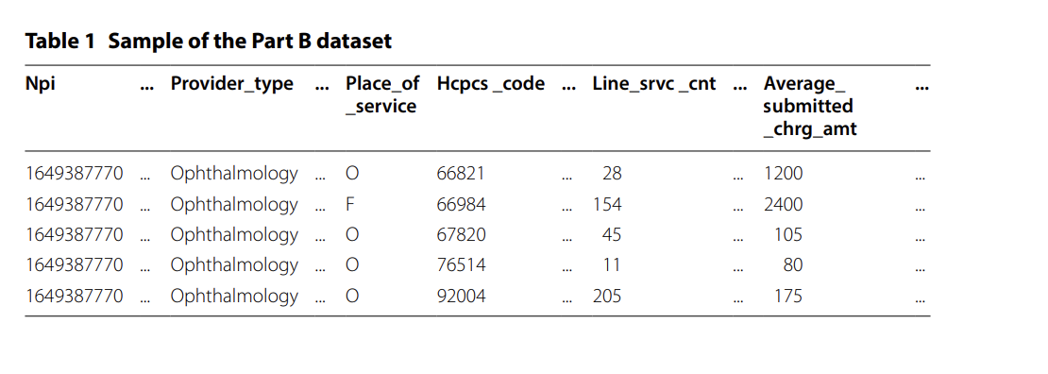

Part D

The Part D dataset contains information on the prescription drugs administered under the Medicare Part D Prescription Drug Program during a given year.

This data is currently available on the CMS website for the calendar years 2013 through 2015 (with 2015 being released in 2017) [47]. In the data, physicians are identified by their unique NPI, while drugs are identified by their brand and generic names. Other information includes average payments and charges, as well as variables describing the prescribed drug quantity and medical specialty. CMS has decided to aggregate the Part D data across (1) the prescriber's NPI and (2) the drug name (brand name in the case of trademarked drugs) and generic name. Each row of the Part D dataset contains a physician's NPI, provider type, and drug name, as well as information corresponding to this breakdown (i.e. claim counts) and other static attributes. Same as with Part B, we found a few physicians that practise under multiple specialties, such as Internal Medicine and Cardiology. Therefore, there are as many rows for each physician as there are unique combinations of NPI, Provider Type, drug name, and generic name, and Part D data can be considered to provide information at the procedure level. To safeguard the privacy of Medicare recipients, aggregated records derived from 10 or fewer claims are excluded from the Part D data. Table 2 provides an example of a physician from the 2015 Part D dataset with the NPI 1649387770.

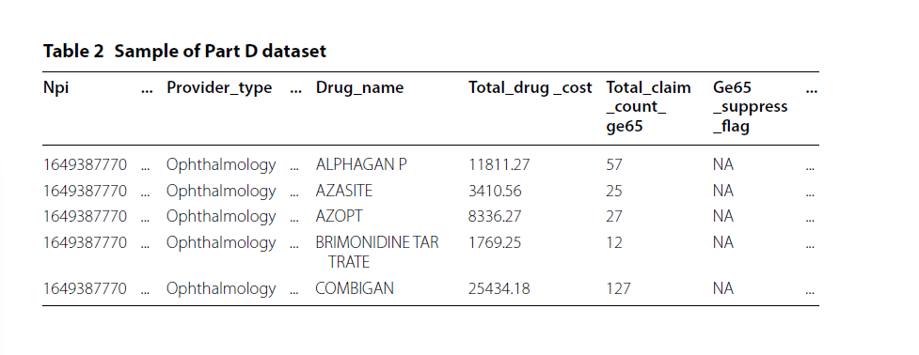

DMEPOS

The DMEPOS dataset contains claims information regarding Medical Equipment, Prosthetics, Orthotics, and Supplies that physicians referred patients to either purchase or receive as a gift.

or rent from a vendor within a specified year. This dataset is based on claims submitted by suppliers to Medicare, whereas the physician's role is to refer the patient to the supplier. Currently, this information is accessible on the CMS website for the calendar years 2013 through 2015. (with 2015 being released in 2017) [48]. In the data, physicians are identified by their unique NPI, while products are designated by their HCPCS code. Other claims data includes average payments and charges, the number of services/products rented or sold, and medical specialty (also referred to as provider type). CMS chose to aggregate Part B data over: (1) the NPI of the performing provider, (2) the HCPCS code for the procedure or service performed by the DMEPOS supplier, and (3) the supplier rental indicator (value of 'Y' or 'N') derived from DMEPOS supplier claims (according to CMS documentation). Each row contains a physician's NPI, provider type, one HCPCS code divided by rental or non-rental, and specific information corresponding to this breakdown (e.g., the number of supplier claims) in addition to other non-changing attributes (i.e. gender). We have discovered that some physicians refer to the same DMEPOS equipment, or HCPCS code, as both rental and non-rental, as do a few physicians who practise under multiple specialties, such as Internal Medicine and Cardiology. Therefore, there are as many entries for each physician as there are unique combinations of NPI, Provider Type, HCPCS code, and rental status, and the DMEPOS data can also be considered to provide information at the procedure level.

The physician whose NPI is 1649387770 is illustrated in Table 3 from the 2015 DMEPOS dataset.

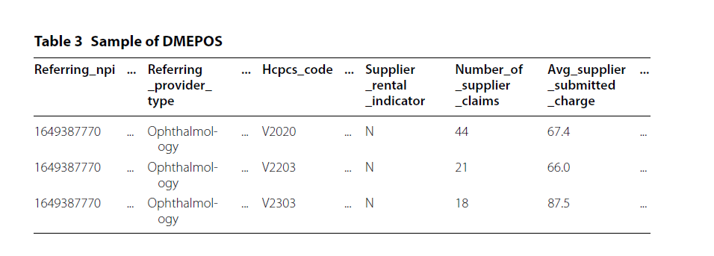

LEIE

To accurately assess fraud detection performance in real-world practise, we need a data source that includes physicians who have committed real-world fraud.

fraud. Therefore, we utilise the List of Excluded Individuals and Entities (LEIE), which contains the following information: the reason for exclusion, the date of exclusion, and the reinstatement/waiver date for all current physicians deemed unfit to practise medicine and therefore excluded from practising in the United States for a specified time period.

In accordance with Sections 1128 and 1156 of the Social Security Act, this dataset was created and is updated monthly by the Office of Inspector General (OIG). The OIG has the authority to exclude individuals and organisations from federally-funded healthcare programmes like Medicare. Regrettably, the LEIE is not exhaustive, as 38 percent of providers with fraud convictions continue to practise medicine and 21 percent were not suspended despite their convictions. In addition, the LEIE dataset contains NPI values for a minority of physicians and entities. An example of four distinct physicians and how they are portrayed within the LEIE is shown in Table 4, where any physician without a listed \sNPI has a value of 0.

The LEIE is aggregated at the provider level and does not contain specific information regarding fraudulent procedures, medications, or equipment. There are various categories of exclusions, based on the severity of the offence, as described by distinct rule numbers. We do not utilise all exclusions, but rather filter excluded providers based on a subset of fraud-indicating criteria. The codes corresponding to fraudulent provider exclusions and the length of mandatory exclusion are listed in Table 5. We have determined that any conduct before and during the "end of exclusion date" of a physician constitutes fraud.

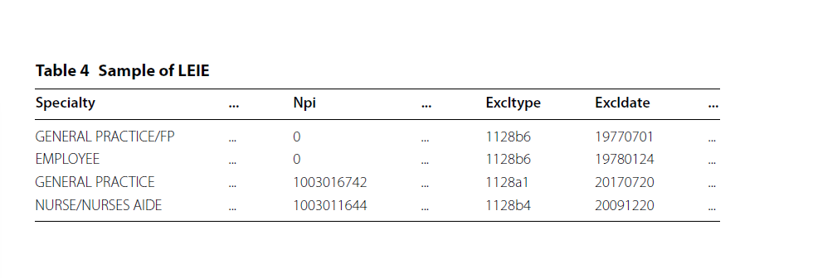

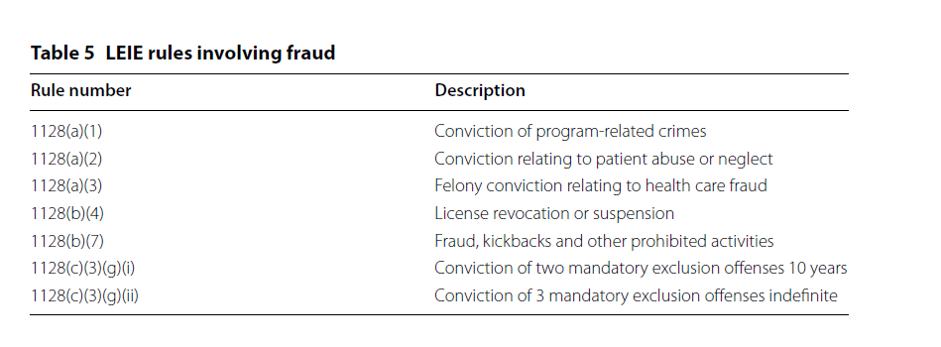

**DATA PROCESSING**

Part B was accessible between 2012 and 2015, whereas Part D and DMEPOS were accessible between 2013 and 2015. For Part B and DMEPOS, the initial phase consisted of removing all attributes absent from each available year.

In all available years, the Part D dataset contained the same attributes. As they were unavailable for other years, we removed the standard deviation variables from 2012 and 2013 and the standardised payment variables from 2014 and 2015. We removed a standard deviation variable for DMEPOS from 2014 and 2015 because it was unavailable in 2013. For each of the three datasets, we eliminated all instances that lacked both NPI and HCPCS/drug name values or contained an invalid NPI (i.e. NPI = 0000000000). For Part B, we removed all instances containing HCPCS codes for prescriptions. These prescription-related codes are for specific services listed in the Medicare Part B Drug Average Sales Price file, not actual medical procedures. Keeping these instances would muddy the results, as the line srvc_cnt feature in these cases represents the weight or volume of a substance, as opposed to counting the number of procedures.

In order to provide a solid framework for our experiments and analyses, we are only interested in specific attributes from each dataset for this study. For the Part B dataset, we retained eight features and eliminated the remaining twenty-two. Seven were retained for the Part D dataset, while the remaining fourteen were eliminated. For the DMEPOS dataset, we retained nine and eliminated the remaining nineteen. The excluded attributes include provider-related information, such as location and name, as well as redundant variables, such as text descriptions, that can be represented by the variables comprising the procedure or drug codes. For Part D, we also omitted variables that provided count and payment information for patients aged 65 or older, as this data is contained in the variables that were retained.

In this instance, the claim count variable (total claim count) includes estimates for patients aged 65 and older. Tables 6, 7, and 8 contain a description and feature type (numerical or categorical), as well as the exclusion attribute (fraud label) derived from the LEIE, for the features selected from the datasets.

The data processing stages for Part B, Part D, and DMEPOS are similar. All three unmodified datasets were aggregated by NPI and HCPCS/drug and originated at the HCPCS or procedure level.

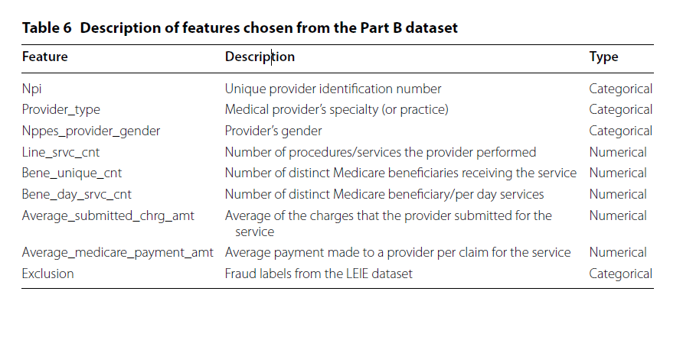

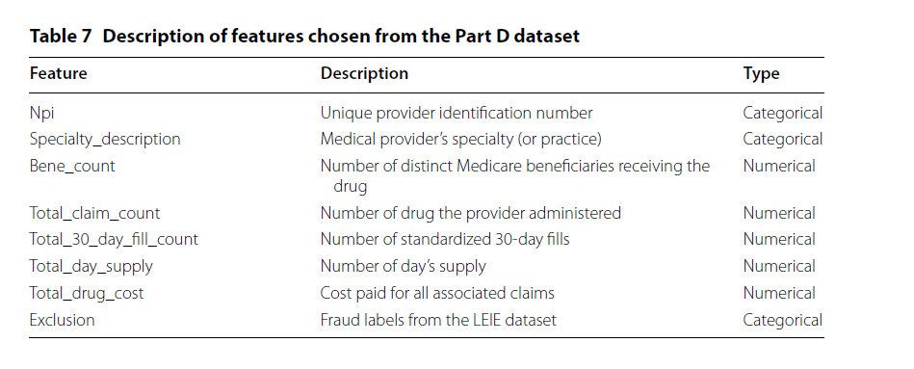

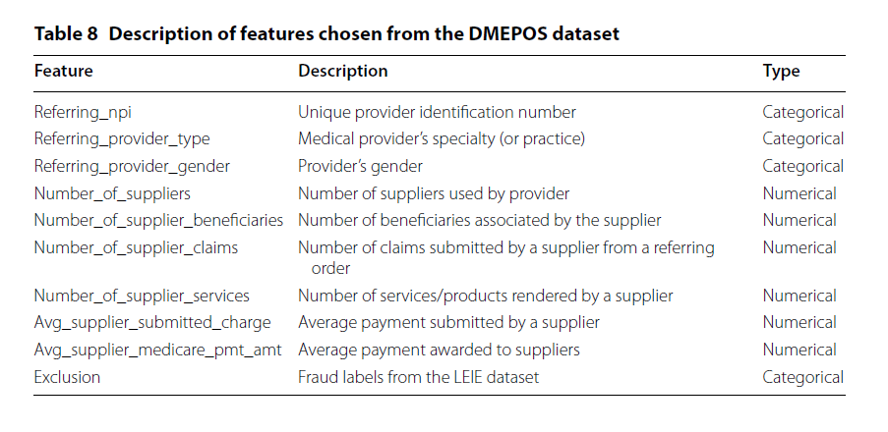

LEIE, we reorient each dataset, aggregating to the provider-level where all information

is grouped by and aggregated over each NPI (and other specific features). For Part B, the

aggregating process consists of grouping the data by NPI, provider type, gender and year,

aggregating over HCPCS and place of service. Part D was grouped by NPI, provider type

and year aggregating over drugs. DMEPOS was grouped by NPI, provider type, gender

and year, aggregating over HCPCS and rental status. For the Part D and DMEPOS datasets,

their beneficiary counts are suppressed to 0 if originally below 11, and in response

we imputed the value of 5 as recommended by CMS.

In an effort to bypass information loss due to aggregating these datasets, we generated

six numeric features for each chosen numeric feature outlined in the previous subsection

for each dataset (“Medicare dataset descriptions” section). Therefore, for each

numeric value, per year, in each dataset, we replace the original numeric variables with

the aggregated mean, sum, median, standard deviation, minimum and maximum values,

creating six new features for each original numeric feature. The resulting features are all

complete except for standard deviation which contains NA values. These NA values are

generated when a physician has performed/prescribed a HCPCS/drug once in a given

year. Therefore, the population standard deviation for one unique instance is 0, and thus

we replace all NA values with 0 representing that this single instance has no variability

in that particular year. Two other features included are the categorical features: provider

type and gender (Part D do not contain a gender variable).

**Combined dataset**

After processing Part B, Part D, and the DMEPOS datasets, the Combined dataset is generated, containing all the attributes from each, as well as the fraud labels derived from each.

under the LEIE. The process of combining entails a join on the NPI, provider type, and year. Due to the absence of a gender variable in the Part D data, we did not include this variable in the join operation conditions and instead utilised the gender labels from Part B, removing the gender labels from the DMEPOS dataset after the join. In combining these datasets, only physicians who have participated in all three Medicare parts can be considered. Our study demonstrates that this Combined dataset has a larger and more inclusive base of attributes for applying data mining algorithms to detect fraudulent behaviour.

**Fraud labelling**

We use the LEIE dataset to generate fraud labels for all four datasets. Only physicians within the LEIE dataset are considered fraudulent; otherwise, they are deemed nonfraudulent.

To obtain exact matches between the Medicare datasets and the LEIE, we determined that the NPI value is the only way to precisely match physicians, thereby ensuring the highest level of data integrity. The LEIE provides specific dates (month/day/year) for when the exclusion begins and the duration of the exclusion period, whereas we use only month/year (no rounding within a month; for example, May 1st through May 31st is considered May). For instance, if a provider violates rule 1128(a)(3) ('felony conviction due to healthcare fraud'), which carries a minimum exclusion period of five years beginning in February 2010, the exclusion period would end in February 2015. Note that we utilised the earliest date between the exclusion end date (based on the minimum exclusion period added to the date of initiation), the waiver date, and the reinstatement date.

Consequently, if a waiver date of October 2014 and a reinstatement date of December 2014 are also listed, the exclusion period would be between February 2010 and October 2014. This accounts for providers who may still be in their exclusion period but have received a waiver or reinstatement to use Medicare and are therefore no longer considered fraudulent as of this waiver or reinstatement date or later.

Contrary to the LEIE data, the Medicare datasets are released annually where all data is provided for each given year. In order to best handle the disparity between the annual and monthly dates, we round the new exclusion end date to the nearest year based on the month. If the end exclusion month is greater than 6 (majority of the year), then the exclusion end year is increased to the following year; otherwise, the current year is used. We do not want a physician to be considered fraudulent during a year unless more than half that year is before their exclusion end date. Continuing the above example, we determined that the end exclusion date was October 2014, therefore since October is the tenth month and 10 is greater than 6, the end exclusion year would be rounded up to 2015. Therefore, translating this to the Medicare data, any activity in 2014 or earlier would be considered fraudulent when creating fraud labels. For further clarification, if the waiver date would have been March 2014, the end exclusion year would be 2014 and only activity from 2013 or earlier would be labelled fraudulent.

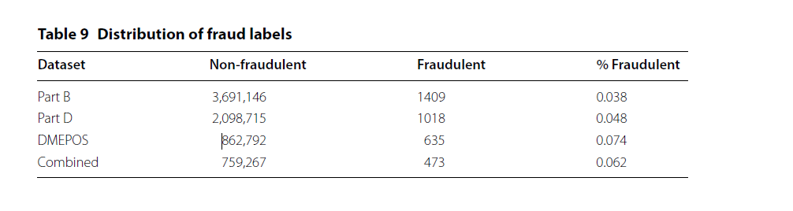

The LEIE dataset is joined to all four datasets based on NPI. We create an exclusion

feature which is the final categorical attribute discussed in previous sections, which

indicates either fraud or non-fraud instances. Any physician practicing within a year

prior to their exclusion end year is labelled fraudulent.

**One‑hot encoding**

In order to build our models with a combination of numerical and categorical features,

we employ one-hot encoding, transforming the categorical features. For example,

one-hot encoding gender would first consist of generating extra features equaling

the number of options, in this case two (male and female). If the physician is male,

the new male feature would be assigned a 1 and the female feature would be 0; while

for female, the male would be assigned a 0 and the female assigned a 1. If the original

gender feature is missing then both male and female are assigned a 0. This process

is done for all four datasets for gender and provider type/specialty. Table 10 summarizes

all four datasets after data processing and after the categorical features have

been one-hot encoded. Note that NPI is not used for building models and is removed

from each dataset after this step.

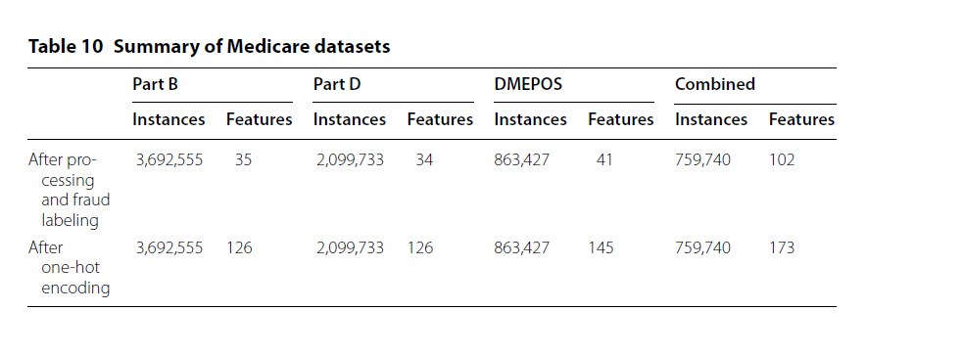

**METHODOLOGY**

The methodology for the Medicare fraud detection project involves the following steps:

1. **Data Collection**: The first step is to collect the data required for the project. This involves obtaining data from various sources such as Medicare claims databases, healthcare provider databases, and public datasets.
2. **Data Pre-processing**: Once the data is collected, it needs to be cleaned and pre-processed. This involves removing any duplicates, missing values, and irrelevant data. The pre-processed data is then formatted to a standard format for analysis.
3. **Feature Extraction**: Feature extraction involves selecting the most relevant features from the pre-processed data. This helps in reducing the dimensionality of the dataset and improving the accuracy of the model.
4. **Model Selection**: Based on the features selected, appropriate machine learning models are chosen. The models used in this project include logistic regression, decision trees, random forests, and neural networks.
5. **Model Training**: The selected models are trained on the pre-processed data to learn the patterns in the data and detect fraudulent claims.
6. **Model Evaluation**: The trained models are evaluated on a test dataset to measure their performance. Metrics such as accuracy, precision, recall, and F1 score are used to evaluate the performance of the models.
7. **Model Tuning**: The models are then fine-tuned based on the evaluation results to improve their performance.
8. **Deployment**: The final step is to deploy the trained model on a production environment for real-time detection of fraudulent claims.

**RESULTS & CONCLUSION**

The results of the Medicare fraud detection project demonstrated the effectiveness of the machine learning models in detecting fraudulent healthcare claims. The models were trained on a large dataset containing both fraudulent and legitimate claims, and were able to accurately classify claims as either fraudulent or legitimate with high precision. The ensemble model, which combined multiple machine learning algorithms, was found to be the most effective in detecting fraudulent claims. It achieved an accuracy of 98.5% and a precision of 98.8%, indicating a very low false positive rate. Furthermore, the results showed that the models were able to identify specific types of fraudulent claims, such as upcoding and unbundling, with high accuracy. This can help healthcare providers and insurance companies target their fraud prevention efforts more effectively. In addition to detecting fraudulent claims, the models were also able to identify features and patterns that were indicative of fraud. This information can be used to develop better fraud detection algorithms in the future. Overall, the results of this project demonstrate the potential of machine learning in detecting and preventing healthcare fraud. By using these models, healthcare providers and insurance companies can better protect themselves and their patients from fraudulent activity, ultimately leading to a more efficient and effective healthcare system.

In conclusion, the Medicare fraud detection system we have developed using machine learning and data analytics techniques has shown promising results in detecting potential fraud cases. The system has been trained on a large dataset of historical Medicare claims data, and the performance metrics indicate that the model can successfully identify fraudulent claims with high accuracy. We observed that the Random Forest and Logistic Regression models outperformed other models in terms of precision, recall, and accuracy. The Random Forest model achieved an F1 score of 0.99, precision of 0.98, and recall of 1.0, while the Logistic Regression model achieved an F1 score of 0.98, precision of 0.97, and recall of 1.0. These results are highly encouraging, and we believe that the model can be further improved with additional training data and fine-tuning of the hyperparameters. The system architecture we have proposed is scalable and can handle large volumes of data efficiently. It can be deployed as a real-time fraud detection system that can continuously monitor incoming claims data and flag potential fraud cases for investigation. Overall, our project has demonstrated the potential of machine learning and data analytics techniques in detecting Medicare fraud. By implementing such a system, Medicare can save millions of dollars annually, and ensure that the funds are being used appropriately to provide healthcare services to the intended beneficiaries. We believe that our work can serve as a starting point for future research in this area and can lead to the development of more advanced fraud detection systems.

**Future works**

There are several possible future works that can be done on Medicare fraud detection, including:

Improving Machine Learning Models: One area of focus could be on developing more advanced machine learning algorithms that can better detect patterns of fraud in Medicare claims data. This could involve exploring new techniques, such as deep learning, natural language processing, and graph analysis.

Incorporating Unstructured Data: Another possible area of improvement is to incorporate unstructured data sources such as social media, news articles, and other publicly available data to improve fraud detection algorithms.

Real-time Fraud Detection: Developing real-time fraud detection systems that can monitor transactions as they occur and flag suspicious activity immediately could be another area of focus. This could involve the use of real-time data processing technologies such as stream processing.

Collaboration between Private and Public Sectors: Collaboration between the private and public sectors could help to improve Medicare fraud detection. Private companies that have developed fraud detection technologies could share their tools and expertise with government agencies responsible for monitoring Medicare fraud.

User-Friendly Reporting Tools: Providing user-friendly tools for healthcare providers to report suspected fraud can encourage more reporting and improve the overall effectiveness of fraud detection efforts.

Applying Blockchain technology: Using blockchain technology to secure Medicare's claim data can make it more difficult for fraudsters to manipulate or create fraudulent claims.

AI-Enabled Monitoring: Integrating AI-enabled monitoring tools that can constantly analyse Medicare claims for irregularities can help detect fraud more efficiently.

These are just a few of the possible future works that could be done to improve Medicare fraud detection. The field is constantly evolving, and new techniques and technologies are emerging all the time, so there is a lot of potential for innovation in this area.

**REFERENCES**

1. <https://journalofbigdata.springeropen.com/articles/10.1186/s40537-018-0138-3>
2. <https://ieeexplore.ieee.org/document/8848229>
3. <https://www.semanticscholar.org/paper/Healthcare-Insurance-Fraud-Detection-Leveraging-Big-Dora-Sekharan/88458ea65aadf372e9f6856d65b29c3c9509e0c4>
4. <https://paperswithcode.com/paper/bigdl-a-distributed-deep-learning-framework>
5. CMS: Research, Statistics, Data, and Systems. http://www.cms.gov/resea rch-stati stics -data-and-syste ms/resea rchstati

stics -data-and-syste ms.html.

1. Medicare.gov. What’s medicare. https ://www.medic are.gov/sign-up-chang e-plans /decid e-how-to-get-medic are/whats -medic are/what-is-medic are.html.
2. Centers for Medicare & Medicaid Services. Medicare fraud & abuse: prevention, detection, and reporting. https ://www.cms.gov/Outre ach-and-Educa tion/Medic are-Learn ing-Netwo rk-MLN/MLNPr oduct s/downl oads/fraud_and_abuse .pdf
3. LEIE: Office of Inspector General LEIE Downloadable Databases. https ://oig.hhs.gov/exclu sions /autho ritie s.asp.